**MEHRAN UNIVERSITY**

**OF ENGINEERING & TECHNOLOGY**

**JAMSHORO, PAKISTAN**

**Course:** Mobile Application Development

**Department:** Software Engineering

**Semester:** 6th  **Year:** 3rd

**Instructor:** Ms. Mariam Memon

|  |  |
| --- | --- |
| **Roll No:** | **22SW119**  **22SW125** |
| **Section:** | **I** |

**Project Name : MindEase**

**Expected Deliverables:**

**1.Working Application (GitHub Links):**

[**https://github.com/Habiba747/MindEase**](https://github.com/Habiba747/MindEase)

**2. A report with following sections:**

**• Real World Problem Identification**

**• Proposed Solution**

**• Responsive User Interfaces (Screenshots of your app on different screens &**

**platforms)**

**• Data Storage (With justification for using a particular database)**

**• [Optional Section] APIs/Packages/Plug-ins (if used with justifications for using**

**them).**

**• Issues and Bugs Encountered and Resolved during Development**

## ****Real World Problem Identification:****

In today’s fast-paced lifestyle, students and working individuals often experience emotional stress, anxiety, and burnout due to workload, social pressure, and personal challenges. Many people find it difficult to track their moods or manage their emotions effectively.  
Without proper awareness of mental patterns, this leads to reduced productivity, emotional imbalance, and poor mental well-being.

Furthermore, not everyone has access to mental health professionals or therapy sessions, so there is a strong need for a simple and user-friendly mobile application that helps users monitor their emotional state and improve mindfulness through self-reflection and relaxation activities.

**Proposed Solution:**

To address the problem, we have developed a mobile application called **MindEase**

**MindEase** helps users record their **daily moods**, **write journal entries**, and access **guided meditation exercises** based on their current emotional state.

The app provides:

* A **Login system** to store and secure user data using **Hive database**.
* A **Mood Journal** screen for users to log how they feel each day and write short reflections.
* A **Meditation section** that suggests specific YouTube meditation videos depending on the user’s mood (e.g., calming music for sadness, relaxing focus sessions for stress).
* A **Progress section** that visually shows how the user’s mood changes over time using graphs and charts.
* **Motivational quotes and messages** that appear when users record their moods to encourage positivity.

The goal of this application is to promote mental wellness and self-awareness through an interactive, easy-to-use, and visually calming interface.

* **Logo** of app is created through **Lovart**

**Logo:**

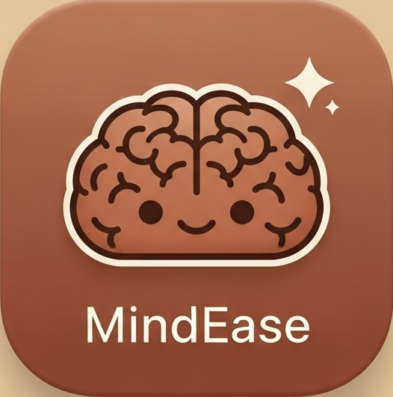

## ****Responsive User Interfaces:****

The **MindEase** application is designed with a **clean, minimalistic, and responsive interface** that adapts seamlessly to different screen sizes such as smartphones and tablets. The app uses **Flutter’s Material Design components**, ensuring consistency and smooth navigation across all platforms.

The design focuses on **user comfort and emotional calmness**, with warm earthy tones (like soft brown and beige) that promote relaxation and mindfulness. All screens are built to be easily readable, visually appealing, and simple for users of all age groups to navigate.

### **Splash Screen**

* The **Splash Screen** is the first interface displayed when the user launches the MindEase app.
* It shows the **app tittle (“MindEase”)**, and tagline “Calm your mind, ease your thoughts 💭”
* After a brief delay of 3 seconds, it automatically navigates users either to the **Login Screen** (for new users) or the **Home Screen** (for returning users).

**Mobile:**  
**Tablet:**

**Laptop:**

**

### **Login Screen**

* Allows users to enter their **email and password** to log in securely.
* Displays input validation messages for incorrect or missing credentials.

**Mobile:**

**Tablet:**

**Laptop:**

### **Home Screen:**

Serves as the main dashboard of the app, allowing users to navigate between features using a **bottom navigation bar**.

* Includes quick access to the **Mood Journal**, **Meditation**, and **Progress** screens.
* The **end drawer** contains options such as About Us, Contact Us, and Logout, presented in a clean and organized layout.
* The user’s name and profile initials are dynamically displayed, personalizing the experience.

**

**Tablet:**

**Laptop:**

### **Mood Journal Screen**

* Within the Home screen there is Mood Journal screen which allows users to select their **current mood** (Happy, Sad, Angry, or Lost) and write a reflective **journal entry** describing their day.
* Displays **motivational messages** and uses expressive **emojis** to make mood tracking more engaging.
* Entries are saved locally using **Hive storage** and can be viewed or deleted later.

**Mobile:**

**Tablet:**

**Laptop:**

### **Meditation Screen**

* Provides **guided meditation steps** to help users relax and focus on mindfulness.
* Features a **breathing exercise**
* Suggests **YouTube meditation videos** based on the user’s current mood and other YouTube videos for meditation and relaxation.

**Mobile:**

**Tablet:**

**Laptop:**

### **Progress Screen**

* Provides daily **motivational quotes** that refresh daily.
* Displays the user’s emotional progress throughout the week using **pie chart.**
* Tracks user streaks.
* Includes a fun **confetti animation** to celebrate journaling achievements and milestones.

**Mobile:**

**Tablet:**

**Laptop:**

**Data Storage:**

For data storage, we have used **Hive**, a lightweight and efficient **NoSQL local database** .

We used Hive because:

* It works **completely offline**, allowing users to access their data even without the internet.
* It is **faster** than traditional databases like SQLite for small-scale personal data storage.
* It is **easy to integrate** with Flutter and does not require complex setup.
* It securely stores user credentials, journal entries, and mood history in local boxes such as userBox and journalBox.

## ****Packages / Plug-ins Used****

### 1. **Hive & Hive Flutter:**

import 'package:hive_flutter/hive_flutter.dart';

* **Purpose:** Used for **local data storage** saving user accounts, journal entries, and the current mood.
* **Why used:** Hive is fast, secure, and works offline without needing a backend.
* **Where used:** In login_screen.dart, mood_journal_screen.dart, and progress_screen.dart.

### 2. **URL Launcher:**

import 'package:url_launcher/url_launcher.dart';

* **Purpose:** Opens YouTube meditation videos based on the user’s current mood.
* **Why used:** Allows users to access external meditation resources directly from the app.
* **Where used:** In meditation_screen.dart.

### 3. **fl_chart:**

import 'package:fl_chart/fl_chart.dart';

* **Purpose:** Displays **progress graphs and charts** showing the user’s mood trends over time.
* **Why used:** Provides a clean and visually appealing way to show mood statistics.
* **Where used:** In progress_screen.dart.

### 4. **Confetti:**

import 'package:confetti/confetti.dart';

* **Purpose:** Adds **celebratory confetti animation** when the user achieves progress milestones.
* **Why used:** Enhances user experience by providing positive reinforcement.
* **Where used:** In progress_screen.dart.

### 5. **Material & Dart Libraries:**

import 'package:flutter/material.dart';

import 'dart:async';

import 'dart:math';

* **Purpose:** These are **core Flutter/Dart libraries** used for building UI, animations, and logic control (timers, random mood quotes, etc.).
* **Where used:** Across all screens.

## ****Issues and Bugs Encountered & Resolved:****

During development, we encountered issues and debugging challenges like :

### 1 **Password Validation Bug:**

Initially, the login screen used an incorrect regular expression for password validation.  
Even valid passwords (with both letters and numbers) were being rejected.  
After debugging, I corrected the regex to:

RegExp(r'^(?=.*[A-Za-z])(?=.*\d).+$')

This fixed the validation issue and ensured that only passwords containing both letters and numbers and 6 characters long are accepted.

### **2 Old APK Not Updating on Device:**

When we rebuilt the APK, the app sometimes showed the **old version** even after uninstalling the previous one.  
This happened because the device cached the previous installation.

we resolved it by cleaning the Flutter build using:

flutter clean

flutter pub get

flutter build apk

and then reinstalling the new APK.